**SD card upgrade**

**Matters needing attention**

1、Precautions before upgrades (important):

The SD card is prohibited from taking out from the device during the upgrade process;

2、Power off not allowed during the upgrade process;

3、You shall get the properly legal upgrade bin by correct way.

**Upgrade steps**

Step 1: Check the upgrade bin

The correct format shall be

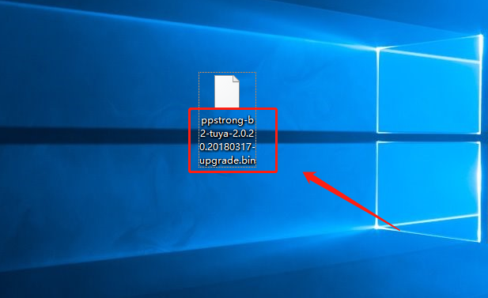

Step 2: Firmware rename

The firmware package file name is changed to upgrade.bin.

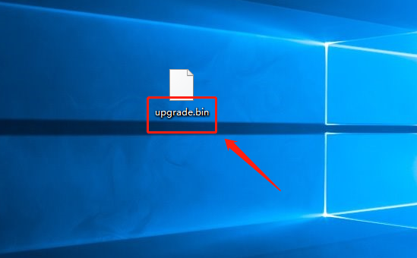

Step 3: Upgrade

Copy the modified firmware package and configuration file to the SD card and insert the device.

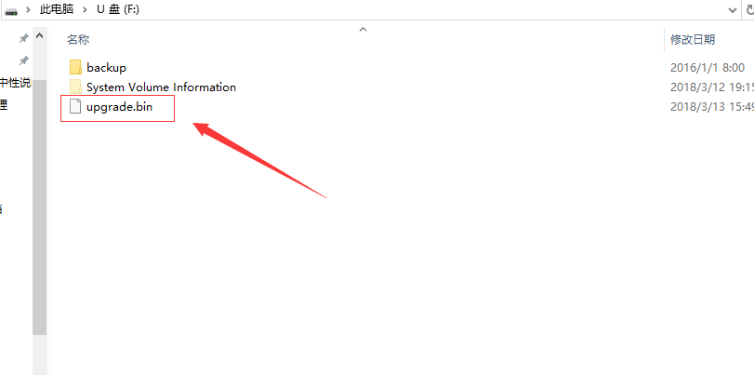

(Key) Press the reset button before giving the device power, and then power the device.

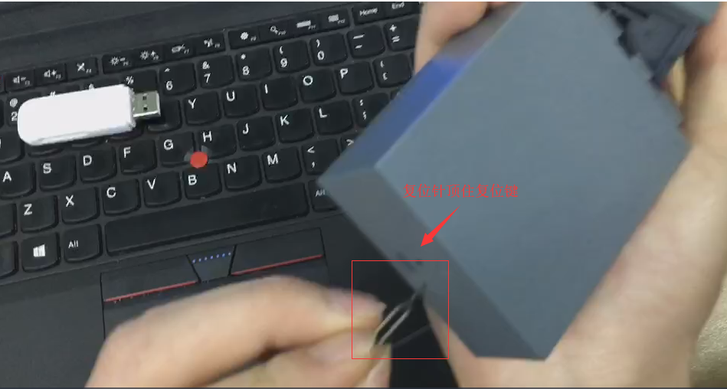

(Key) Until the device status light appears blue light, loosen the reset pin.

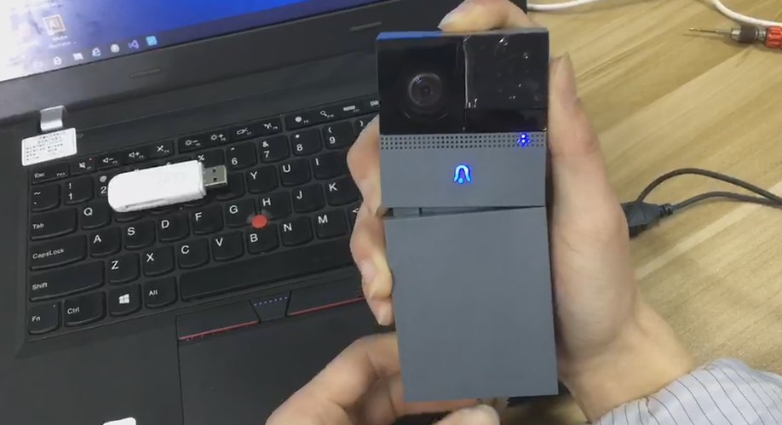

About 3~5 minutes, the device status light is red, then the upgrade is successful.

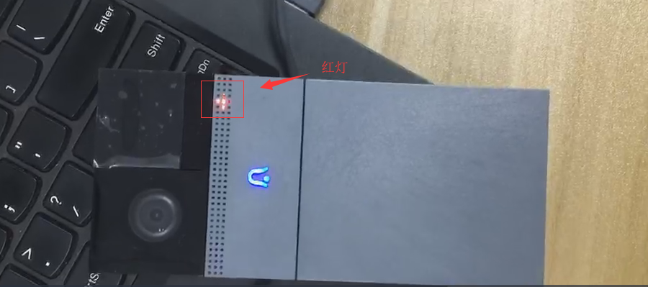

At this point, the upgrade can be judged by whether the file in the SD card is changed to upgrade_ok.

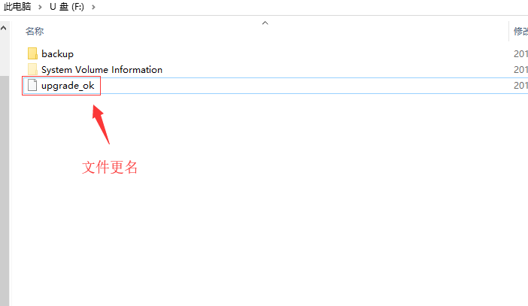

The upgrade is successful.

**Friendly reminder**

1. The file name must be modified to upgrade.bin.
2. The configuration file and the renamed firmware package should be copied to the SD card.
3. Be sure to use the reset pin to resist the reset button before powering the device, and then power the device.